Motion Blur

Tianshi Xie
Computer Science, Troy University
Troy, United States
txie@troy.edu
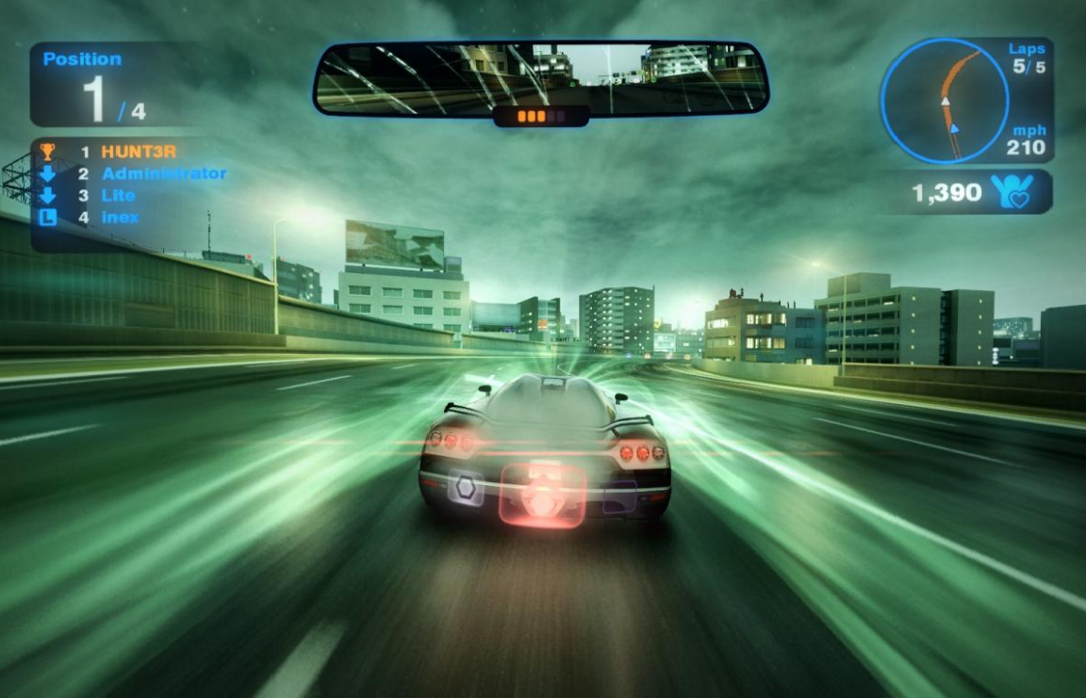

Figure 1 www.nvidia.coms

Abstract— This paper describes a technology of motion blur of moving objects rapidly that is implemented by using multi-pass rendering. In the first pass, rendering the geometry into a RenderTarget. In the second pass, changing the vertex position between the previous and current vertex. And then the pixel shader applies the results to generate a blurred visual.

Keywords— Shader, RenderTarget(RT), multi-pass rendering, RenderMonkey, screen effects.

- Shader : It is a computer program that is used to do shading.
- RenderTarget : is a feature of modern graphics processing units (GPUs) that allows a 3D scene to be rendered to an intermediate memory buffer
- Multi-pass rendering: It is a process in which an application traverses its scene graph multiple times in order to produce an output to render to the display
- RenderMonkey: It is a software for rending system and developed by AMD company.
- Screen effect: Some graphics technique that is applied to the entire screen

Introduction and Related Work

Assuming there is a fast-moving pen in front of your eyes from left to right, you will notice that a big blur because you cannot see the pen clearly.
The same phenomenon also take place with photo and video cameras. For example, photographed a person who is always swaying so that a blur figure in the photo because the human eye and cameras do not take in information at an infinite rate but take snapshots of what they see many times per second. If an object is moving faster than the rate at which images are captured, it will appear to streak across the image.

Knowing how the effect happens in real life can tell us to implement it in our render system. The ideal approach is to determine the movement speed of each pixel in the scene from one frame to another, and use this information to blur the image correctly.

This approach is too complicated to implement at this point in this article. Another approach would be to ignore the speed of movement and take the pixels from the previous frame and blend them with the pixels of the current frame. This approach is a gross estimation because it does not account for actual speed but has been taken in many of today’s video games and is the approach I will take in this article.

My method may seem like a rough approximation of the real effect, and you may think it would not run. A common misconception in computer graphics is that unless you do it the exact way it appears in real life, it cannot look good. When you read this article, you will learn that the essence of computer graphics is not how exactly you do something, but how convincing it is to the human eye. Human vision is a very subjective thing and does not perceive everything equally, just as you can’t assume the intensity of a color is the simple average of all its components. Before you can write a motion blur shader[16] you should understand the process of how the effect happens using Render System. You will need to render your scene to a render target and then blend the current result with the previous output from the previous frame. You can see the whole motion blur process is simply a recursive loop, where the result from the previous frame is used to render the next frames

It is necessary to introduce some basic elements for motion blur. First, how to render a scene to a texture. Second, how to use the texture.

Rendering to a drawing board

Generally, it is simple to implement a screen effect[10]. First, you do not need to use the screen buffer, only render the scene to a texture. And then, you have many choices to filter this texture which stored the scene.

After filter this texture, you can put it into the screen buffer. And then it will be appeared to the user. So, before implementing some of this kind of effects. You should know how to render a scene to a texture. It will be worth for other kinds of effects. Our developing software is RenderMonkey,

We will use a render target which is popular used in DirectX[17] and OpenGL[35]. It can be called by different rendering API, and invoke the hardware to output the result to the texture you choose.

You can create the render target as a pass. In the same way, you also can create the second pass, the third pass and so on. Notice that the user cannot see anything because the whole scene is rendered to the render target, rather than to the frame buffer. At this time, you can assume everything goes well. The next step is that create a new pass to copy the result from this render target to the frame buffer. Finally, it will be presented on the screen.

So now, you can apply the texture to the object and projecting it onto the screen. The whole process is shown in figure 5.3

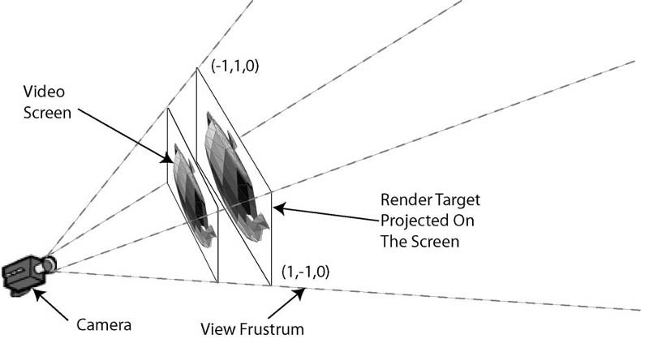

Figure 2 www.nvidia.com

Texture transformation

If using the whole texture, you will need to know that the texture coordinates are (0,0), (1,0), (1,1), (0,1) in 2d space.
You will consider one thing that the pixels on the screen and the texture are not completely match because the hardware just make the coordinates of screen correspond to the center of the texture pixel. So, you need to offset the texture slightly such as half a pixel to correct this problem which is some unexpected filtering.

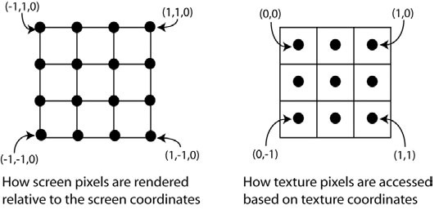

Figure 3 www.nvidia.com

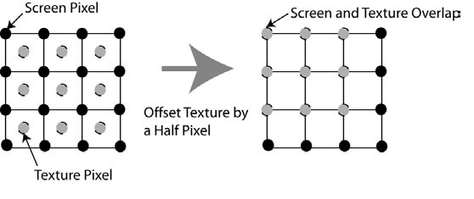

Figure 4 www.nvidia.com

Rendering the Render Target

It is time to create the pixel shader. The input parameter should be the texture coordinates[21]. And a sampler texture.
Finally, return the sampled color according to the coordinates.

sampler Texture0;

float4 ps_main(float2 texCoord: TEXCOORD0) : COLOR
{

// Simply read the temporary texture and send

// the color to the output without manipulating it

return tex2D(Texture0, texCoord);

}

You should have enough information to implement a motion blur effect so far.

The workflow process

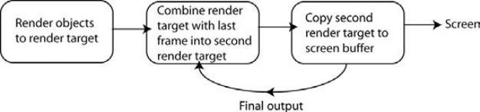

Figure 5 www.nvidia.com

The first render target was used by the second render target.
.

Creating the Motion Blur Shader
After you should understand the process of the effects using RenderMonkey. you can create a motion blur shader. As a matter of fact, the process is to render the whole scene to a RT and then blend the current result with the previous output from the previous frame.

Selecting a Template in RenderMonkey
First, confirm that you have the correct template for your shader. This template has been supported in RenderMonkey.

Add a new pass for blending the result
- Using the template shader developed in RenderMonkey.
- It already renders the whole scene to a render target and supports a pass to duplicate a render target to the screen.
- According to the diagram in Figure 1, the last thing is a pass that is responsible for blending the result from the previous frame with the current result. Therefore, you need to add another pass to your effect.
- If the new pass is added at the end of the effect, you will move up the new pass because the render system actually renders them sequentially in the order they are appeared within the List in the RenderMonkey

Adding a new render target
In addition, adding a new render target which is used to not only keep the previous frame’s render result, but also track of this to your effect.

At this time, you have the RenderTarget which render the objects from the scene and blending pass, and then you can blend the two render targets together. Adding a variable named blur_control to the effect to control how the two textures will be combined is worthwhile because you can adjust this value to see the changs of effect immediately.
        

Blending in Pixel Shader
- Adding the RT2 and blur_control to the Pixel Shader
- Blend two texture together.
- Using the blur_control to adjust the desirable effects

Algorithm

Overview

The algorithm consists of the following two rendering passes:

Unblurred geometry
- The moving scene geometry is drawn, tetured and shaded (simple Gourad interpolation).
- This is rendered directly onto a framebuffer object(FBO)

Blurred geometry:
- The static scene geometry is drawn, textured and shaded(simple Gourad interpolation)
- The skybox is drawn (using a cubemap texture) onto a screen-aligned quad at max depth distance.
- The “strtched”moving geometry is drawn(with depth test disabled). In this step, the FBO color attachment rendered earlier is used for supersampling.
- All of this is rendered directly onto the default framebuffer.

Formula
- Vertex Shader

Out.texCoord.x = 0.5 * (1 + Pos.x - viewport_inv_width);

Out.texCoord.y = 0.5 * (1 - Pos.y - viewport_inv_height);

Since the reason of the hardware, the texture coordinate has to get a half offset to overlap the pixel on the screen correctly.

- Pixel Shader

float4 col1 = tex2D(Texture0, texCoord);

float4 col2 = tex2D(Texture1, texCoord);

return lerp(col1,col2,blur_factor);

Using the weight blur_factor to control the blur extent. If the blur_factor is more bigger, then the blur extent is more bigger because it tend to the col2 which come from current frame. Or it will tend to the col2 which is the result of the previous frame, the blur extent is more smaller.

alysis and summary

This article is a simple implementation of a filter for motion blur.It mainly take advantage of difference position between the previous frame and the current frame. Using a weight variable (blur_control) to control the blur extent in a linear function in pixel shader.

This method has some constraints:
- The effect act on some specific object which is fast-moving because it is not a post-process effect.

- The performance is dependent on the scene complexity. Such as there is only one car in the camera, the car consists of 5000 vertexes. GPU just process and blur the 5000 vertexes. That’s ok. But if,

there are 100 cars in the camera. 500000 vertexes will be blur by the GPU, that’s bad design because the frame will be stuck, the value of the frame may be less than 10.

- This method is computed each object which is fast-moving. So, it’s not dependent on camera motion

For example:
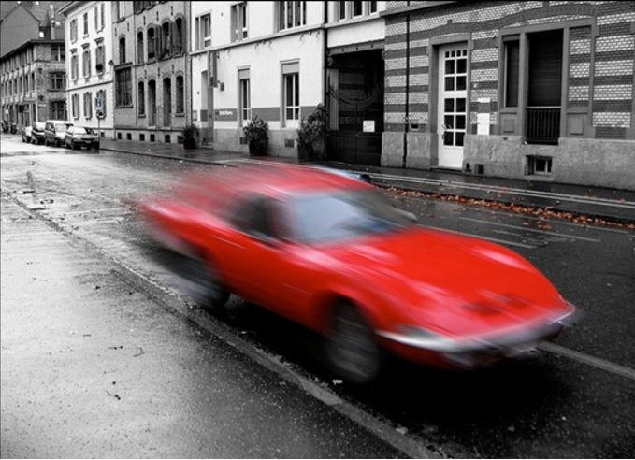

Figure 6 www.nvidia.com

In addition, there is another algorithm is a post-process that to be processed on a 2d texture. The performance is not dependent on specific objects.This method is an implementation of computing the pixel by vector direction.
- It is only computed in screen space so that the rendering system does not need to be changed for the effect
- The performance is not dependent on the objects in scene. But it will be affected by the screen resolution. The screen resolution is more bigger, the performance is more lower, or more higher.
- This method can be used the whole scene, and does not care how complex the scene is because it was processed only on a 2d texture.
- If the camera is attached an object no matter the object is moving or not, as long as the object is in the range of camera, it will be blurred.

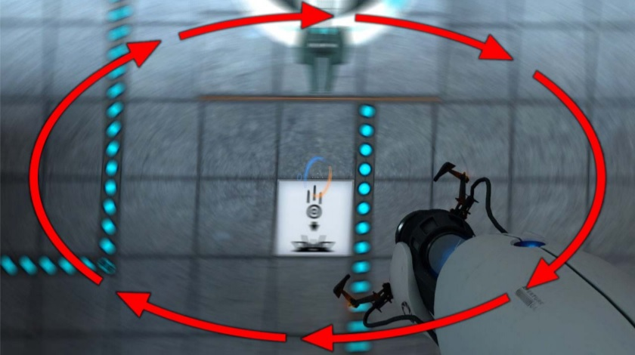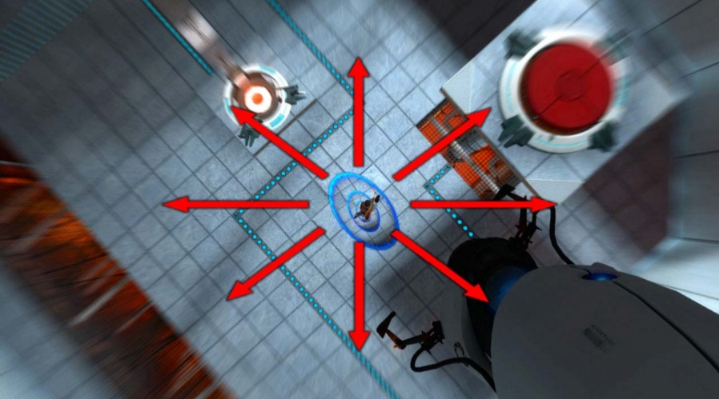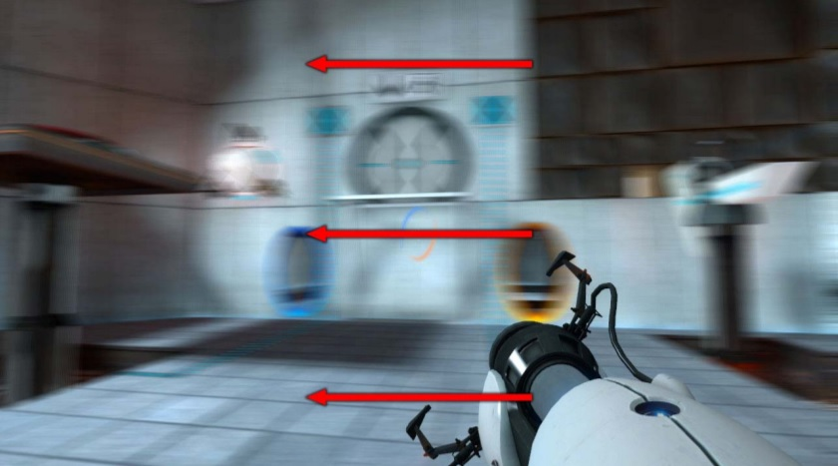

Figure 7 www.nvidia.com

futhur work

Now, we have two works in the future. One is smoothing the motion blur. Another one is optimizing the performance of the motion blur.

- Smoothing the motion blur

- We have two method to implement motion blur so far. But they have the same problem that there is a hard edge. How to solve it! There are a lot of smooth function.
- We usually use the Gaussian algorithm which is commonly used with edge detection

- Optimizing the performance of the motion blur

- We will pay more attention to the performance of Gaussian in different platform. Such as the algorithm of Gaussian of PC is not fit in mobile. So we will do the work which is optimizing the algorithm as much as possible in the future.

- Minimizing the amount of the rendering pass because passing the texture must be a big cost.

- Reducing the draw call as possible. Drawing multi objects which has the motion blur at one time.

- Using the Multiple Render Target (MRT) to store multi texture.

- Avoiding more calculating in Vertex Shader or Pixel Shader.

knowledgment

Many thanks to Dr.Yanjun Zhao. The subject of this thesis was challenging to me. She made this experience really valuable for me. Thank you so much!

References

[1] AKENINE-M¨OLLER, T., MUNKBERG, J., AND HASSELGREN, J.2007. Stochastic rasterization using time-continuous triangles.In Graphics Hardware, Eurographics Association, Aire-la-Ville,Switzerland, 7–16.

[2] BOULOS, S., LUONG, E., FATAHALIAN, K., MORETON, H.,AND HANRAHAN, P. 2010. Space-time hierarchical occlusionculling for micropolygon rendering with motion blur. In High Performance Graphics, Eurographics Association, Aire-la-Ville,Switzerland, 11–18.

[3] BOUVIER-ZAPPA, S., OSTROMOUKHOV, V., AND POULIN, P.2007. Motion cues for illustration of skeletal motion capture data. In NPAR, ACM, New York, NY, USA, 133–140.

[4] BRUNHAVER, J. S., FATAHALIAN, K., AND HANRAHAN, P.2010. Hardware implementation of micropolygon rasterization with motion and defocus blur. In High Performance Graphics,Eurographics Association, Aire-la-Ville, Switzerland, 1–9.

[5] COOK, R. L., PORTER, T., AND CARPENTER, L. 1984. Distributedray tracing. In SIGGRAPH, ACM, New York, NY, USA,vol. 18, 137–145.

[6] EGAN, K., TSENG, Y.-T., HOLZSCHUCH, N., DURAND, F., AND RAMAMOORTHI, R. 2009. Frequency analysis and sheared reconstruction for rendering motionblur. In SIGGRAPH, 93:1–:13.

[7] EPIC GAMES, 2010. MotionBlur post process effect. Unreal Developer Network, Unreal Engine 3 Documentation,
http://udn.epicgames.com/Three/MotionBlur.html.

[8] FATAHALIAN, K., LUONG, E., BOULOS, S., AKELEY, K.,MARK, W. R., AND HANRAHAN, P. 2009. Data-parallel rasterization of micropolygons with defocus and motion blur. In High Performance Graphics, ACM, New York, NY, USA, 59–68.

[9] GRANT, C. W. 1985. Integrated analytic spatial and temporal antialiasing for polyhedra in 4-space. SIGGRAPH (July), 79–84.

[10] GREEN, S., 2003. Stupid OpenGL shader tricks. Talk at Game Developers Conference.

[11] GRIBEL, C. J., DOGGETT, M., AND AKENINE-M¨O LLER, T.2010. Analytical motion blur rasterization with compression. In High Performance Graphics, Eurographics Association, Aire-la- Ville, Switzerland, 163–172.

[13] GRIBEL, C. J., BARRINGER, R., AND AKENINE-M¨O LLER, T. 2011. High-quality spatio-temporal rendering using semianalytical visibility. In SIGGRAPH, ACM, New York, NY, USA, 54:1–54:12.

[14] HARGREAVES, S. 2004. In Detail Texture Motion Blur, W. Engel,Ed. Charles River Media, ch. 2.11, 205–214.

[15] HERZOG, R., EISEMANN, E., MYSZKOWSKI, K., AND SEIDEL,H.-P. 2010. Spatio-temporal upsampling on the GPU. In I3D2010, ACM.

[16] JONES, N., AND KEYSER, J. 2005. Real-time geometric motion blur for a deforming polygonal mesh. In Computer Graphics International 2005, IEEE Computer Society, Washington, DC, USA, 26–31.

[17] KASYAN, N., SCHULZ, N., AND SOUSA, T., 2011. Secrets of CryENGINE 3 graphics technology. SIGGRAPH 2011 Talks.

[18] LEHTINEN, J., AILA, T., CHEN, J., LAINE, S., AND DURAND,F. 2011. Temporal light field reconstruction for rendering distribution effects. ACM Trans. Graph. 30, 4.

[19] LOTTES, T., 2009. FXAA, February. http://developer.download.nvidia.com/assets/gamedev/files/sd

[20] k/11/FXAA WhitePaper.LOVISCACH, J. 2005. Motion blur for textures by means of anisotropic filtering. In EGSR.

[21] MAX, N. L., AND LERNER, D. M. 1985. A two-and-a-half-D motion-blur algorithm. In SIGGRAPH, ACM, New York, NY, USA, 85–93.

[22] MAX, N. 1990. Polygon-based post-process motion blur. Visual Computer 6 (November), 308–314.

[23] MCGUIRE, M., ENDERTON, E., SHIRLEY, P., AND LUEBKE, D.2010. Hardware-accelerated stochastic rasterization on conventional GPU architectures. In High Performance Graphics.

[24] MUNKBERG, J., CLARBERG, P., HASSELGREN, J., TOTH, R.,SUGIHARA, M., AND AKENINE-M¨O LLER, T. 2011. Hierarchical stochastic motion blur rasterization. In High Performance Graphics, ACM, New York, NY, USA, 107–118.

[25] OBAYASHI, S., KONDO, K., KONMA, T., AND IWAMOTO, K.-I. 2005. Non-photorealistic motion blur for 3d animation. InSIGGRAPH Sketches, ACM, New York, NY, USA.

[26] OVERBECK, R. S., DONNER, C., AND RAMAMOORTHI, R. 2009.Adaptive Wavelet Rendering. SIGGRAPH Asia 28, 5, 1–12.

[27] PEPPER, D. 2008. Per-pixel motion blur for wheels. In ShaderX6,W. Engel, Ed. Charles River Media, ch. 3.4, 175–188.

[28] POTMESIL, M., AND CHAKRAVARTY, I. 1983. Modeling motion blur in computer-generated images. In SIGGRAPH, ACM, New York, NY, USA, 389–399.

[29] RITCHIE, M., MODERN, G., AND MITCHELL, K. 2010. Split second motion blur. In SIGGRAPH Talks, ACM, New York, NY, USA, 17:1–17:1.

[30] ROSADO, G. 2007. Motion blur as a post-processing effect. In GPU Gems 3. Addison Wesley, ch. 27, 575–581.

[31] SAWADA, Y., 2007. Talk at Game Developers Conference CEDEC.SEN, P., AND DARABI, S. 2011. On Filtering the Noise from the Random Parameters in Monte Carlo Rendering. ACM Transactions on Graphics (TOG) to appear.

[32] SHIMIZU, C., SHESH, A., AND CHEN, B. 2003. Hardware accelerated motion blur generation. Eurographics.

[33] SHIRLEY, P., AILA, T., COHEN, J., ENDERTON, E., LAINE, S. LUEBKE, D., AND MCGUIRE, M. 2011. A local image reconstruction algorithm for stochastic rendering. In I3D, ACM, New York, NY, USA, 9–14.

[34] SOUSA, T., 2008. Crysis next gen effects. Talk at Game Developers Conference.

[35] SOUSA, T., 2011. CryENGINE 3 rendering techniques, August.Talk at Microsoft Game Technology conference Gamefest 2011.

[36] SUNG, K., PEARCE, A., AND WANG, C. 2002. Spatial-temporal
antialiasing. IEEE TVCG 8 (April), 144–153.

[37] TATARCHUK, N., BRENNAN, C., ISIDORO, J., AND VLACHOS,
A. 2003. Motion blur using geometry and shading distortion. In
ShaderX2, W. Engel, Ed. Charles River Media.

[38] VLACHOS, A., 2008. Post processing in the Orange Box, February.
Talk at Game Developers Conference 2008.

